Question 1

INCLUDE Irvine32.inc

.data
menu1 BYTE "=== Number Operations Menu ===", 0
menu2 BYTE "1. Square of a number", 0
menu3 BYTE "2. Cube of a number", 0
menu4 BYTE "3. Sum of digits", 0
menu5 BYTE "4. Exit", 0
menu6 BYTE "==============================", 0
askChoice BYTE "Enter your choice (1-4): ", 0
askNumber BYTE "Enter a number: ", 0
result BYTE " is: ", 0

.code
main PROC
menuLoop:
call Crlf
mov edx, OFFSET menu1
call WriteString
call Crlf
mov edx, OFFSET menu2
call WriteString
call Crlf
mov edx, OFFSET menu3
call WriteString
call Crlf
mov edx, OFFSET menu4
call WriteString
call Crlf
mov edx, OFFSET menu5
call WriteString
call Crlf
mov edx, OFFSET menu6
call WriteString
call Crlf
mov edx, OFFSET askChoice
call WriteString
call ReadInt

cmp eax, 4
je exitProg
cmp eax, 1
jl menuLoop
cmp eax, 3
jg menuLoop

mov ebx, eax
mov edx, OFFSET askNumber
call WriteString
call ReadInt
mov ecx, eax

cmp ebx, 1
je calcSquare
cmp ebx, 2
je calcCube
cmp ebx, 3
je calcSum

calcSquare:
mov eax, ecx
call WriteInt
mov edx, OFFSET result
call WriteString
mov eax, ecx
imul eax, ecx
call WriteInt
call Crlf
jmp menuLoop

calcCube:
mov eax, ecx
call WriteInt
mov edx, OFFSET result
call WriteString
mov eax, ecx
imul eax, ecx
imul eax, ecx
call WriteInt
call Crlf
jmp menuLoop

calcSum:
mov eax, ecx
call WriteInt
mov edx, OFFSET result
call WriteString
mov eax, ecx
cmp eax, 0
jge positiveNum
neg eax

positiveNum:
xor ebx, ebx
mov ecx, 10

sumLoop:
cmp eax, 0
je printSum
xor edx, edx
div ecx
add ebx, edx
jmp sumLoop

printSum:
mov eax, ebx
call WriteInt
call Crlf
jmp menuLoop

exitProg:
exit
main ENDP

END main
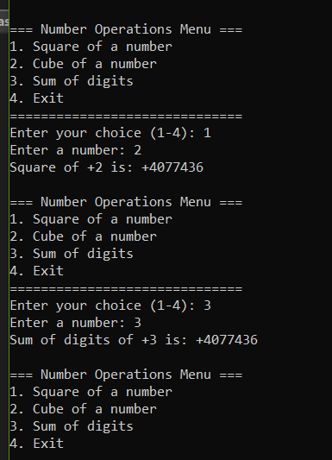
Question 2

INCLUDE Irvine32.inc

.data
resultMsg BYTE "Dot Product Result: ", 0

.code
main PROC
push 3
push 4
push 5
push 6

call VectorSum

mov edx, OFFSET resultMsg
call WriteString
call WriteInt
call Crlf

exit
main ENDP

VectorSum PROC
push ebp
mov ebp, esp

mov eax, [ebp + 20]
mov ebx, [ebp + 16]
add eax, ebx

mov ecx, [ebp + 12]
mov edx, [ebp + 8]
add ecx, edx

push ecx
push eax

call DotProduct

pop ebp
ret 16
VectorSum ENDP

DotProduct PROC
push ebp
mov ebp, esp

mov eax, [ebp + 12]
mov ebx, [ebp + 8]

imul eax, ebx

pop ebp
ret 8
DotProduct ENDP

END main
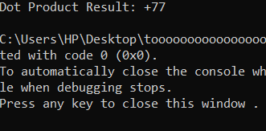

Question 3

INCLUDE Irvine32.inc

.data
myArray DWORD 12, 45, 7, 23, 56, 89, 34, 67, 21, 90
arraySize DWORD 10
resultMsg BYTE "Maximum value in array: ", 0

.code
main PROC
push arraySize
push OFFSET myArray

call FindMax

mov edx, OFFSET resultMsg
call WriteString
call WriteInt
call Crlf

exit
main ENDP

FindMax PROC
push ebp
mov ebp, esp
push ebx
push ecx
push esi

mov esi, [ebp + 8]
mov ecx, [ebp + 12]

mov eax, [esi]

cmp ecx, 1
jle done

xor ebx, ebx

loopPairs:
cmp ebx, ecx
jge checkLast

mov edx, [esi + ebx * 4]

inc ebx
cmp ebx, ecx
jge compareSingle

push [esi + ebx * 4]
push edx
call ComparePair

cmp eax, [esi + ebx * 4]
jge skipUpdate
mov eax, [esi + ebx * 4]

skipUpdate:
inc ebx
jmp loopPairs

compareSingle:
cmp eax, edx
jge done
mov eax, edx
jmp done

checkLast:
jmp done

done:
pop esi
pop ecx
pop ebx
pop ebp
ret 8
FindMax ENDP

ComparePair PROC
push ebp
mov ebp, esp

mov eax, [ebp + 8]
mov ebx, [ebp + 12]

cmp eax, ebx
jge returnFirst
mov eax, ebx

returnFirst:
pop ebp
ret 8
ComparePair ENDP

END main
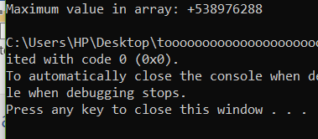

Question 4

INCLUDE Irvine32.inc

.data
myArray SDWORD 100 DUP(?)
arraySize DWORD ?
largest SDWORD ?
secondLargest SDWORD ?
promptSize BYTE "Enter the number of elements: ", 0
promptElement BYTE "Enter element: ", 0
resultLargest BYTE "Largest element: ", 0
resultSecond BYTE "Second largest element: ", 0

.code
main PROC
mov edx, OFFSET promptSize
call WriteString
call ReadInt
mov arraySize, eax

mov ecx, arraySize
mov esi, OFFSET myArray

inputLoop:
mov edx, OFFSET promptElement
call WriteString
call ReadInt
mov [esi], eax
add esi, 4
loop inputLoop

push arraySize
push OFFSET myArray

call ProcessArray

mov edx, OFFSET resultSecond
call WriteString
call WriteInt
call Crlf

exit
main ENDP

ProcessArray PROC
push ebp
mov ebp, esp
push ebx
push ecx
push esi
push edi

mov esi, [ebp + 8]
mov ecx, [ebp + 12]

mov eax, [esi]
mov largest, eax

mov eax, [esi + 4]
mov ebx, largest
cmp ebx, eax
jge skipSwap

mov largest, eax
mov eax, ebx

skipSwap:
mov secondLargest, eax

mov edi, 2

processLoop:
cmp edi, ecx
jge done

mov eax, [esi + edi * 4]
push secondLargest
push largest
push eax

call CompareCandidates

mov largest, eax
mov secondLargest, ebx

inc edi
jmp processLoop

done:
mov edx, OFFSET resultLargest
call WriteString
mov eax, largest
call WriteInt
call Crlf

mov eax, secondLargest

pop edi
pop esi
pop ecx
pop ebx
pop ebp
ret 8
ProcessArray ENDP

CompareCandidates PROC
push ebp
mov ebp, esp

mov eax, [ebp + 8]
mov ebx, [ebp + 12]
mov ecx, [ebp + 16]

cmp eax, ebx
jle notNewLargest

mov edx, ebx
mov ebx, eax
mov eax, edx
jmp returnValues

notNewLargest:
cmp eax, ecx
jle returnValues

mov ecx, eax

returnValues:
mov eax, ebx
mov ebx, ecx

pop ebp
ret 12
CompareCandidates ENDP

END main
